M.Tech CSE Website Document

Executive Summary
The Department of Computer Science & Engineering was established in the year 2003 and offers disciplines B. Tech (CSE) in the year 2003 and M. Tech (CSE) in the year 2011. The programme had started with a number of qualified faculty and technical members who have been engaging the students in innovative teaching-learning process to provide a comprehensive research environment. GNIT has QS Gold Ranking and NAAC Accredited and CSE dept. had got NBA in 2009.
The department provides a good infrastructure to the students. Dedicated classrooms, high end laboratories, workstations, three different lease line which help the students to avail wi-fi campus. The success of the Department is amply reflected in the outstanding achievements of the UG and PG students employed in India and abroad. Department along with Training & placement cell provide on campus and off campus job assistance to all the students. Even some of the students opt for higher studies. Students believe every success is due to the contribution of the well-qualified and dedicated faculty who constantly motivate the efforts of the students to reach the top. In addition to the curriculum, the department in association with IE chapter and IIC cell conducts regular value-added course, soft skill programs, seminars, and webinars with the help of quailed resource person from India and abroad to meet the ever-changing needs of employ-ability. This helps the highly motivated students to understand the dynamics of the industry and to upgrade their skills for higher studies and research and development activities. During curriculum all the students enroll for multiple in-house and industry ready trainings, MOOC courses through which they can enhance their skill. As a result many of them get paid internship during their 2 years PG or 4 years UG programme.
Highly reputed MNC Infosys Pvt. Ltd. and Guru Nanak Institute of Technology had renewed Memorandum of Understanding on 1st May, 2020 with respect to enriching the technical education process. CSE has taken the initiative to continue Infosys Campus Connect Programme like previous years. CSE Dept. has also signed a MOU with Globsyn Knowledge Foundation and 3rd Life, a sister concern of Globsyn Group on 27th July, 2019. Prof. (Dr.) Santanu Kumar Sen, Principal,GNIT, Mr. Bikram Dasgupta, Chairman, Globsyn Group, Managing Director, CEO, 3rd Life , were present in this collaborative endeavour which was commissioned in G D Birla Sabhaghar.
Students have been making the department proud since its inception. CSE students keep remarkable footsteps in wining prizes in national and international events. Like in recent years particularly in 2019 one CSE team named ‘BYTE ME UP’ Stood First in Smart India Hackathon '19 a coding challenge initiative by honourable Prime Minister and was awarded 1 Lac Rupees. The same year the team named ‘WE LOVE FOOD’ selected in Smart India Hackathon Grand Finale. In 2018 two of our students Srotoswini Chanda and Dhiren Lalwani were selected in the top list to compete in regional round of international coding competition ICPC Final 2018. Another student Susmita Goswami from 3rd year became Champion in University Chess Tournament 2019 of MAKAUT, Deepak Shaw got Rashtriya Sahitya Academy award and many more achievements are in the book of the dept. In 2020, CSE team named ‘D@TA PIRATES’ worked under Ministry of Housing and Urban Affairs, Govt. of India and became champion of SIH-2020 and awarded 1 Lac Rupees.
Every year CSE students get opportunity to go for training in AIT, Bangkok and Russia. Last year in 2019 Saswata Mukhopadhyay and Debaleena Dutta stood 1st and 2nd respectively and got chance to participate in the final round in the presence of Indian and Russian President. Along with regular study students often publish papers in reputed national and international conferences and journals. Department has collaborative learning programme-CS50 in collaboration with Havard University where the students exchange their knowledge on their own.

Courses Offered:

Course Name | Duration | Year of Inception | Intake
B. Tech | 4 years | 2003 | 180
M. Tech | 2 years | 2011 | 18

Objective of the Programme:
To create technical professionals with practical mindset and problem solving abilities, for solving problems in a variety of business, scientific and socials contexts, to serve people. Students are imparted with the knowledge of the design, development and analysis of software and hardware related to computational devices.

Vision
- The Vision of the department is to produce proficient graduates suitable for industries and competent for international level including research and development with Social responsibility.

Mission
- Providing learner-centric Teaching-learning process in excellent infrastructure for making the graduates industry ready with social ethics.
- Imparting technical education which enhances Independent thinking, vast domain of knowledge, problem solving skill and optimistic attitudes towards holistic growth of young minds to serve the nation worldwide
- Strengthening the academic and research sphere of Computer Science domain, the organization makes a journey towards the Centre of Excellence.

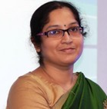
HEAD OF THE DEPARTMENT MESSAGE

Computer Science & Engineering department has been in the forefront of imparting quality education to the students. The success of the Department is amply reflected in the outstanding achievements of the students employed both abroad and within the country. Every success is due to the contribution of the well-qualified and dedicated faculty motivating the efforts of the students to reach the top. In addition to the curriculum, our department conducts regular value-added course and soft skill programs to meet the ever-changing needs of employability. This helps the highly motivated students to understand the dynamics of the industry and to upgrade their skills for higher studies. This Department of GNIT was established in the year 2003 and offers disciplines like B. Tech (CSE) and M. Tech (CSE) by a number of qualified faculty and technical members who engage the students in innovative teaching-learning process to provide a comprehensive research environment complemented. The Department is constantly evolving towards greater heights to serve the needs of the society and meet the aspirations of the student community.

- Dr. SANGEETA BHATTACHARYA

Infrastructure
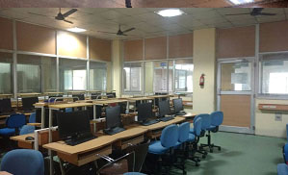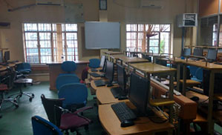

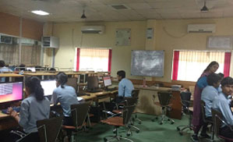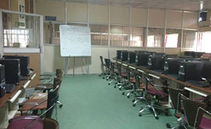

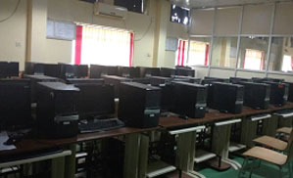
- C programming, Data Structure Lab
- Design analysis of algorithm Laboratory
- DBMS Lab
- Network Laboratory
- Operating Systems Laboratory
- Visual Programming & Web technology Laboratory
- Communication & Cryptography Laboratory
- Departmental Library

Distinguished Alumni:


DEVDUTTA CHAKRABARTI
I am Devdutta Chakrabarti an alumni of M.Tech, CSE Department and presently I am working as Senior Software Engineer in HCL Technologies, Bangalore. Earlier I was in Infosys, Mysore. I have had a great experience while learning M.Tech in CSE Department. I have received more than enough support and I'm glad that I chose Guru Nanak Institute of Technology to study my PG degree. I had zero confidence within myself but now I am so proud of what I have achieved within a short period of time as I got immense support from faculty members and the institute. I heard that the faculty and staff members were so helpful and supportive that the students can achieve as per their potential. With that motivation I have joined the M.Tech(CSE) programme and attended all theoretical and laboratory classes that led me to do my best in every aspect. My sincere gratitude to all the faculty and staff members of CSE department.

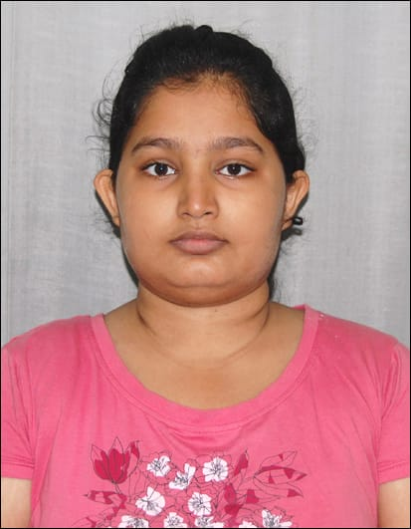
SUSMITA SIKDAR
My name is Susmita Sikdar and currently pursuing M. Tech in CSE Department in Guru Nanak Institute of Technology. I have really enjoyed my study in the department. I have been a part of this college since last 5 years. I have completed my B.TECH from this college and currently pursuing M.TECH that helped me to achieve great success in life. My teachers who have been teaching in this college are not only extremely knowledgeable but also they are very helpful to share experience when we want to know anything beyond syllabus. All other staff members of our college are also very much cooperative. My biggest achievement during M.Tech was in 2019 I joined two weeks ‘Knowledge Sharing Week Programme’ in Russia that was organized by Russian Embassy and JIS Group. Presently I am working as Junior Security Analyst at Indian Cyber Security Solutions and for all this success I am grateful to my department.

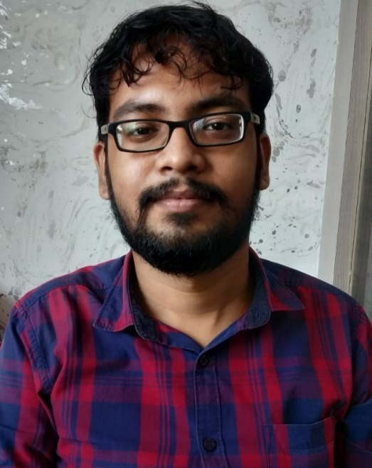
DEEPAYAN PAL
I am Deepayan Pal and currently pursuing M. Tech in CSE Department in Guru Nanak Institute of Technology. I have great experience during the course. I enjoyed the friendly environment during study and I got nice cooperation from all the faculty members whenever I required that. I am Founder & Director of Sikharthy Infotech Private Ltd.

Present Students’ byte:
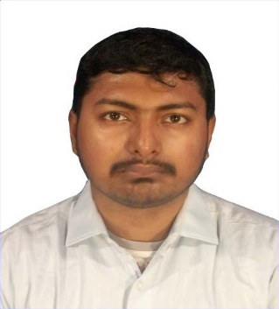
SOUVIK MAZUMDER, 2nd Year
My Name is Souvik Mazumder, I am a student of Guru Nanak Institute of Technology. My Batch is 2019-21, Mtech. We did only 1st semester in offline mode & after that 2nd , 3rd & 4th semester in online mode digital teaching which was started during the lockdown period due to COVID-19. But, we did not facing any problem, because of our faculty members are very supportive. All of our teachers are very knowledgeable, skilled, motivated, friendly & kind.

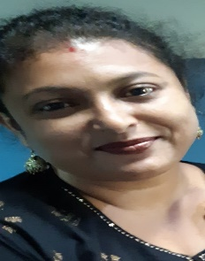

PARAMITA SARKAR, 2nd Year

Hi
This is Paramita Sarkar, did my M.Tech ( CSE) this year from GNIT . I would like to share my feelings and experience about this University during my tenure . I am a former student of this university and completed by B.Tech from here in 2007. I pursued my career for shirt stint and then I decided to uptake some of my family responsibilities, though I still carried my dream of completing my Masters. Years passed by and I lost some interest in pursuing my passion, it is then one of my Professors , rang me up to know about my well being and her words rekindled the fire in me. I took admission for M. TECH. and my proffesors helped me get immensely , to achieve my dream. Faculties are very helpful. They are vastly experienced and knowledgeable. Their unique ways of teaching made me understand things with consumate ease. It also gave me a world of confidence.
I am indebted to my teachers and I wish GNIT lots of success .

